Local Agreement Template
17.4.15
The draft local level agreement included here is a generic one, and this should be used when considering development of a local level agreement for the area your service supports.
Agencies should be aware that the Office of the Director of Mental Health, the Mental Health Service Improvement Group and Disability Support Services have developed a standard Statement of Joint Approach governing the relationship between both parties when supporting a person diagnosed with ASD, the use of which has been mandated by both parties to the Statement of Joint Approach .
The draft local level agreement has been developed to provide agencies with a framework for formalising:
- the sharing of information in view of supporting a person to access appropriate disability support services when they have disability needs resulting from a diagnosis of ASD
- processes for needs assessment and, when required, for joint (disability and mental health) planning for and provision of services by each agency for eligible people with a diagnosis of ASD .
The Statement of Joint Approach identifies the key areas of responsibility and obligations for the agencies providing support. The local level agreement is applied at a local level as a tool to garner a positive outcome for the disabled person.
Other agencies, as funders or providers of essential supports, may need to be a party to this or a separate MOU.
Local Agreement Template, to be used in conjunction with the Statement on Joint Approach ASD.
Agreement between:

……………………………………………………….
Needs Assessment and Service Coordination Service
and
……………………………………………………….
District Health Board

Background to this local level agreement
The Ministry of Health has implemented this strategy which provides an open environment for the sharing of information between agencies and collaboration on needs assessment and service provision for the betterment of people being supported across agencies.
The local level agreement covers a wide spectrum of information, including, but not limited to, administrative records, operational data, and reports about identifiable individuals.
When information about identifiable individuals is required to be shared, such information may legitimately be shared agencies within the provisions of Privacy Act and the Health Information Privacy Code.
Lead By:
The following people are the key contacts for each agency for the purposes of operationalising this Agreement:
……………………………………………………….

……………………………………………………….
Process
Decisions made will be compatible with the principles of the Statement on Joint Approach ASD, copied below.
General Principles
- Transparency: Shared arrangements should be transparent to the disabled person/family and should not impose unreasonable delays to service provision.

- Flexibility: A person’s age often determines which service provides an ASD diagnosis for an individual. However, flexibility is required for situations when the person is more appropriately assessed by the service intended for slightly younger or older people. The person’s needs and the practicalities of the situation will influence this decision.

- Based on needs: When considering joint arrangements, the primary focus will be on the individual’s needs.
- No cost shifting for existing service users.
General Overview of Responsibility for Provision of Services by Mental Health and Disability Support Services
Ministry of Health Disability Support Services is responsible for purchasing disability support services for people with long term disabilities. DHBs are responsible for all other local health services.
In most instances, mental health will provide services rather than funding although they may refer to a mental health NASC for assessment and the provision of respite and/or home based support in relation to mental health needs.
Service users with a co-existing ASD diagnosis may also be referred to Disability Support Services NASC. The two NASCs will work together to co-ordinate service provision.
Roles and Responsibilities
Mental health Services’ role includes diagnosis of Autism Spectrum Disorder and treatment for coexisting mental health or alcohol and other drug problems including working with disability support services to assist people to access appropriate support services. This includes diagnosis and treatment for children, youth and adults.
Disability Support Services are responsible for funding disability support for people with intellectual, physical and/or sensory disabilities that are likely to last for more than six months.
Service Coordination
DSS NASC services have contact with eligible disabled people who access disability support services at least annually, and currently there is a requirement for a three yearly reassessment.
Mental Health services provide triage and case management based on the needs of the individual. The mechanism for coordination of service provision needs to be agreed between the two parties. This may include confirmation of which service leads service coordination and the review of ongoing needs.
Generally the following approach will be used to plan referrals and responsibilities:
- Eligibility for services needs to be determined by each party according to the relevant eligibility criteria currently applying to that party.
- Define the individual’s needs, including the essential components that must be met. This process should be guided by the principles as outlined in Part 2.21 of the Statement of Joint Approach
For example:
- Physical cares -
i. Managing medication
ii. Equipment
iii. Toileting
iiii. Respite care/Carer relief
v. Behaviour support

- Mental health
    - Medication
    - Alcohol and other drug treatment needs, including home based support
    - Mental health treatment needs, including respite care and home based support
- Security
- Contact with family and natural supports
- Socialisation in care setting (e.g. school, residential), level of engagement the person is capable of and would benefit from with peers and caregivers.
- Schooling/employment
- Transport
- Identify what each party will contribute to meeting these needs.
- Build each party’s contributions into a plan which defines responsibilities – who does what and by when.
- Identify who will fund the agreed actions (needs based but avoiding cost shifting)
- If a dispute is not resolved, parties will use the escalation pathway in the Statement on Joint Approach ASD, included here as Appendix 1

Process for Engagement
The local mental health services (including mental health NASC) and Disability Support Services (NASC) services will develop and maintain working relationships with each other to ensure effective communication, agreed pathways for resolving problems and agreed referral processes.
Local mental health services will work towards providing a consultation and liaison support function to the NASC of that region to support decisions about whether a referral to the local primary MH service or the specialist MH service is required.
Relationships and contacts will be developed or enhanced between NASC and local Primary Health Organisations (PHO) including local primary mental health, thereby ensuring NASC become familiar with the local primary mental health services and systems.
Decisions made will be recorded in the plan and signed by the parties.

Signed by:
Signature_________________________ Date__________________________

Signature_________________________ Date__________________________

Appendix 1 Escalation Pathway.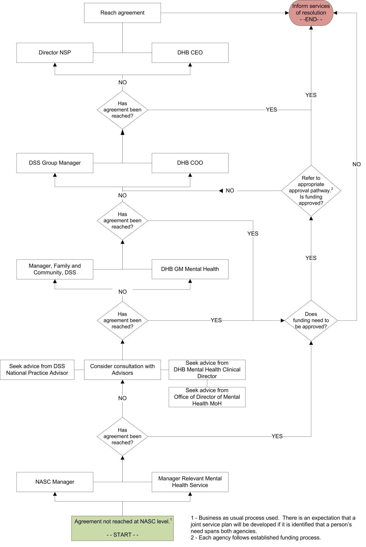

A person already receiving support from Mental Health services or Disability Support Services will stay with this service unless their needs change, in which case the new joint process will apply.
Typically, MH will fund and provide diagnostic assessments and MH treatment rather than provide funding for externally provided services. However, there will be occasions when MH will fund home based support, respite care/carer relief or make a funding contribution to packages of care for people with coexisting MH and disability needs.

